

**By**

**Sunil Raj Thota**

**Sashank Yakkali**

**Feng Gao**

**Date: 05/18/2021**

**Title: XN Project: EDA & Project Plan**

**ALY 6080 – Integrated Experiential Learning**

**Prof. Atherley, Valerie**

**Introduction:**

In this project, we have a plan to follow and go with that. Project members must visually communicate the project's goals and key milestones as an important part of strategic planning. Project roadmaps come in handy in this situation. They aid stakeholders in comprehending the project's objectives, priorities, allocated resources, and planned deliverables, all of which are plotted on a timeline. We are following the below approach to determine the order in which project deliverables should be prioritized based on dependencies and business goals. Calculate the time and effort required for each deliverable. Remember to account for resource and team availability, as well as any potential risks that may cause the project to be delayed. Each deliverable should have its own set of milestones. Create a list of high-level activities that will lead up to the timeline's milestone.

**Project Requirements**

In this assignment, we will delve deeper into the Annual Conc. By Monitor in 2020 Dataset, which we obtained from the EPA website. Each parameter is calculated at a different location. It is used to keep track of events over 24 hours and to control them accordingly. We can examine the dataset using R/ Python. To find them, we need exploratory data analysis, which tests the data for unexpected findings that could affect the effects of our analysis and statistical modeling.

This is how we'll do exploratory data analysis. EDA gives you the ability to see through the numbers. We gain more insights as we dive further into the data. We'll be using EDA to analyze data and solve various business problems for approximately 80% of our time. Going forward, we'll be looking at a lot of columns. The Visualization Dashboard is our favorite method of displaying data. We are aiming to use Machine Learning models to predict the better outcomes of the AQI data. Allowing ourselves to go beyond and analyze the data with tools like Power BI or Tableau or AWS Quick Sight.

**Milestones**

Some of the key milestones that we going to follow and adhere are:

* Project Deadlines
* Communication with the Stakeholders
* Targeting Key Performance Indicators
* Step-by-step progress
* Evaluate our progress
* Fixing the issues
* Project Completion and Presentation

These milestones enable the group to determine which activities would lead them in the right direction to meet these objectives.

**Job Assignments**

As we are a team of 3 people. Every one of us must get some flexibility and ability to work on all the tasks that we are going to present. By this, we all know what’s going on with the project and it will be easy to analyze where we stand. The work will be assigned to a person and has to deal with it by abiding by the deadlines and quality. Below pic is the dashboard done in Tableau as an exploratory data analysis.

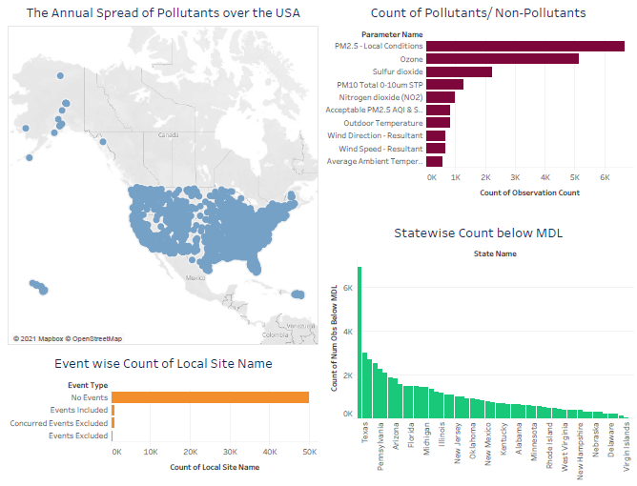

For this, we will be using a Project Management software like JIRA/ Bitbucket to the best. Work assignments have many benefits, but one drawback is that work can be delegated to someone unavailable, such as if a team member is sick/ on holiday. By doing so, we can see a significant rise in Project efficiency and productivity.

**Risks and Strategies**

The assessment, in our opinion, is the most difficult part. The evaluation requires the stakeholders of the failing project to create and sign a charter before any assessment work can begin. To deliver a product or service, we must ensure that our team will work together. When specifications are unclear, and there is no proper contact with sponsors/clients about the progress made so far and whether they are satisfied or not, project efforts normally go to waste. In this situation, we believe that we are aware of the requirements.

Lack of awareness is one of the risks that we see. When making such predictions, the greatest danger is that the future environment will vary, and thus the past may not be sufficient to predict the future. Even if the core analytics team is limited, it helps if they engage with as many other colleagues as possible to get additional viewpoints on their line of thought. Getting the right data together, correctly analyzing models, and asking the right questions of the production takes as much imagination, business knowledge, and experience as possible

**Measure of Success**

A systematic project assessment is useful at the end of a process or stage because it will show you how the project is progressing in comparison to the original projections. Examine the big milestones to see if they are all on the same dates as you decided. A quality analysis will determine if what you're doing adheres to the quality plans' guidelines. Find out how they are now feeling about the project and what you should do differently.

By assessing project progress, you're also assessing project failure, which is equally necessary to investigate. Failure isn't the end of the world. Examine the project's final deliverables. Some projects produce excellent results but cause undue stress. Check to see if the project benefited its stakeholders.

**Presentation Method & Results**

We ended up making a couple of plots, which we used during the stakeholder presentation. We found that some chart designs prompted more fruitful debates during the presentation. Data visualization is the method of viewing data visually – in other words, using pictures to comprehend data. We create a Dashboard in one of the tools as specified and provide some recommendations to improve Keva Health’s platform by analyzing the data. We may use visual representations to open the eyes of key stakeholders and decision-makers, helping them to understand what a dataset is showing, how a model can help solve a business issue, and what effect the findings can have on the organization easily and rapidly.

**Conclusion:**

In the end, you'll be hard-pressed to find someone willing to wade through a complex project plan any time they have a minor question or need a quick update on your project. A roadmap helps you and your team get closer to the finish line by visualizing the important components of the project plan. When we go further into the information, we gain new insights. For nearly 80% of our time, we'll be using EDA to analyze data and solve different business challenges. We also want to use machine learning algorithms to predict how asthma problems will turn out. I'll use the Visualization Dashboard to evaluate and present the data in the future. Look for datasets on emergency room visits that are available to the public and download the air now datasets. Analyze the impact of air quality on asthma patients by performing an investigation and creating a graphic representation. Recommendations for using this information to help asthma patients

**References:**

[1] Midori Nediger, (Oct 01, 2020). How To Create a Product Roadmap (Product Roadmap Templates) was retrieved from https://venngage.com/blog/product-roadmap/

[2] Nick Hotz (December 27, 2019). Data Science Project Roadmap was retrieved from https://www.datascience-pm.com/example-roadmap/